Fixguru Sample Order
BW 1mx100m (SL Clear) 4.5kg x 200
OPP TAPE-45-80-45 x6
SF-C17-W43 x 67

hey
i want to buy flyers 25x35x100
17x30x100
1ctn

G5 x200
G7 x300
K5 x600
R10 x600
A5 x80
B4 x80
B5 x80
T5 x80
G8 x40
A3B x60
A10 x100
B10 x40
K6 x40
S1 x40

Fragile Tape x 1ctn

AWB 100x150mm (500pcs) x 1ctn

so, sea lark, pm 127, 100 pack
so, sea lark g1, 600 pcs
so, mohuan global, y1, 300pcs
so, flybear, a5, 300pcs

so, flybear,
flybear(310) 1000pcs
flybear(200) 500pcs
flybear(430) 800pcs

so, flybear
pm78 20 pack
pm77 40 pack
pm74 50 pack

So, bookxcess, BW 0.5 m x 100 m, 100roll
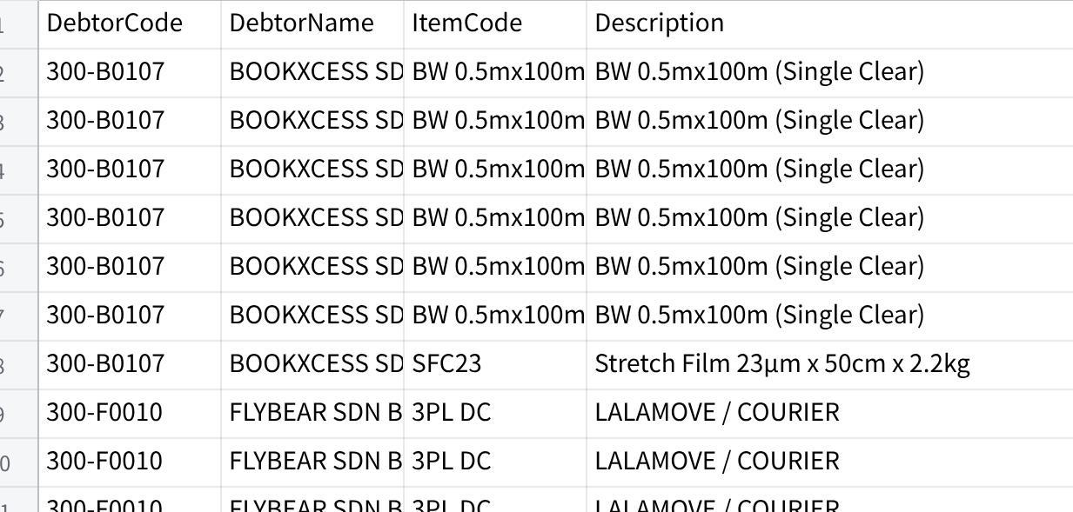
点击图片可查看完整电子表格
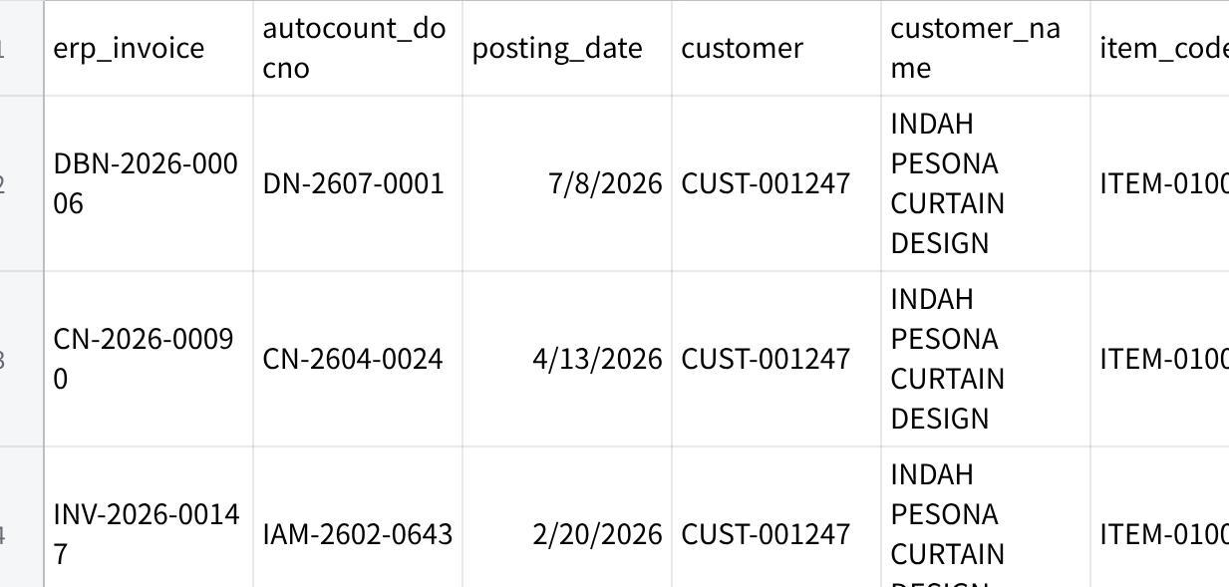
点击图片可查看完整电子表格

